
2025/2026
Lab 2: Singly Linked list

FAKULTI SAINS KOMPUTER DAN MATEMATIK
DATA STRUCTURE & ALGORITHM

VERSION 1
Name: Arisya Syahirah binti Azizi
Matric Number: S76119
Lab: MP2
Date: 27/10/2025
STUDENT INFORMATION

Please fill in your personal details:
Name: Arisya syahirah binti azizi
MATRIC NUMBER:s76119
GROUP:k3
LAB:MP2
DATE:27/10/2025
Table of Contents
INSTRUCTIONS 1
TASK 1: IMPLEMENTATION OF SINGLY LINKED LIST 2
TASK 2: APPLICATION OF SINGLY LINKED LIST 7

INSTRUCTIONS

Manual makmal ini adalah untuk kegunaan pelajar-pelajar Fakulti Teknologi Kejuruteraan Kelautan dan Informatik, Universiti Malaysia Terengganu (UMT) sahaja. Tidak dibenarkan mencetak dan mengedar manual ini tanpa kebenaran rasmi daripada penulis.
Sila ikuti langkah demi langkah sebagaimana yang dinyatakan di dalam manual.

This laboratory manual is for use by the students of the Faculty of Ocean Engineering Technology and Informatics, Universiti Malaysia Terengganu (UMT) only. It is not permissible to print and distribute this manual without the official authorisation of the author.
Please follow step by step as described in the manual.

TASK 1: implementation of singly linked list

Objective
In this lab, we will learn the following topics:
- A linked list
- Implementation of linked list using java
- Insert Node at the beginning of the list
- Traverse List
- Delete Node from a list

task description
In each of the topics, students should implement the tasks step by steps in order to have better understanding of singly linked list.

Estimated Time
[60 Minutes]

DEfinition of linked list
A linked list is just a chain of nodes, with each subsequent node being a child of the previous one. Many programs rely on linked lists for their storage because these don't have any evident restrictions. There is no limit (other than the amount of memory) on the number of elements they can store.

Singly linked lists
Basics:
- A singly linked list is a concrete data structure consisting of a sequence of nodes
- It has a head node pointer indicating the first node in list.
- It could have optionally a tail pointer node indication the last node in list.
- Each node stores
  - Element (data)
  - Link to the next node

Operations:
The common operations of Singly linked list are:
- Insertion (or Add):
- Add first
- Add last
- Add middle (after existing node); example:
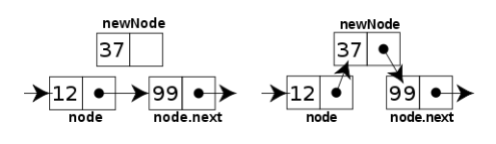
Figure 1: An example of insertion a new node in the middle of linked list

- Deletion (or Remove):
- Delete first
- Delete last
- Delete after existing node; example:
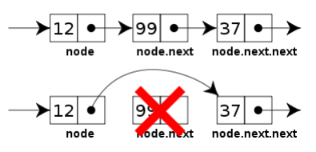
Figure 2: An example of insertion a new node in the middle of linked list

Some common handling methods of Singly/Doubly linked list are:
- Print (Or Show):
- Print all list elements
- Print certain node
- Search for an element
- Find list size (if no size variable in list class)
- Reverse the linked list [step 2]

ACTIVITIES
Activity 1:
Apply and test the Linked List implementation bellow:
// the code below is a simple example of a linked list that inserts a new link at the beginning of the list, deletes from the beginning of the list and loops through the list to print the links contained in it.
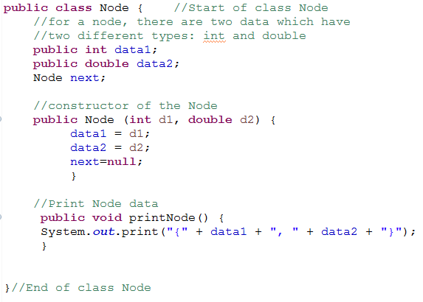
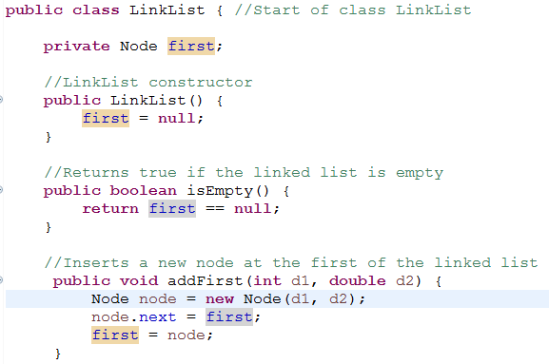
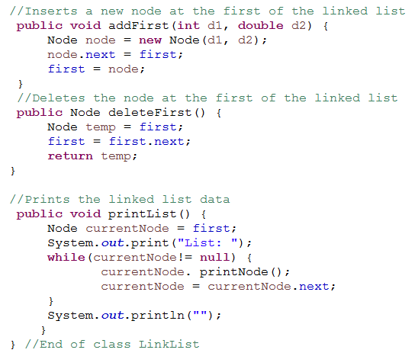
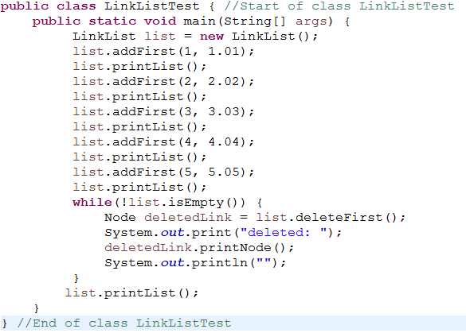
Activity 2: Compile the program. Execute the program and record the results.
Upload the screenshot using the control box provided below:
Answer:
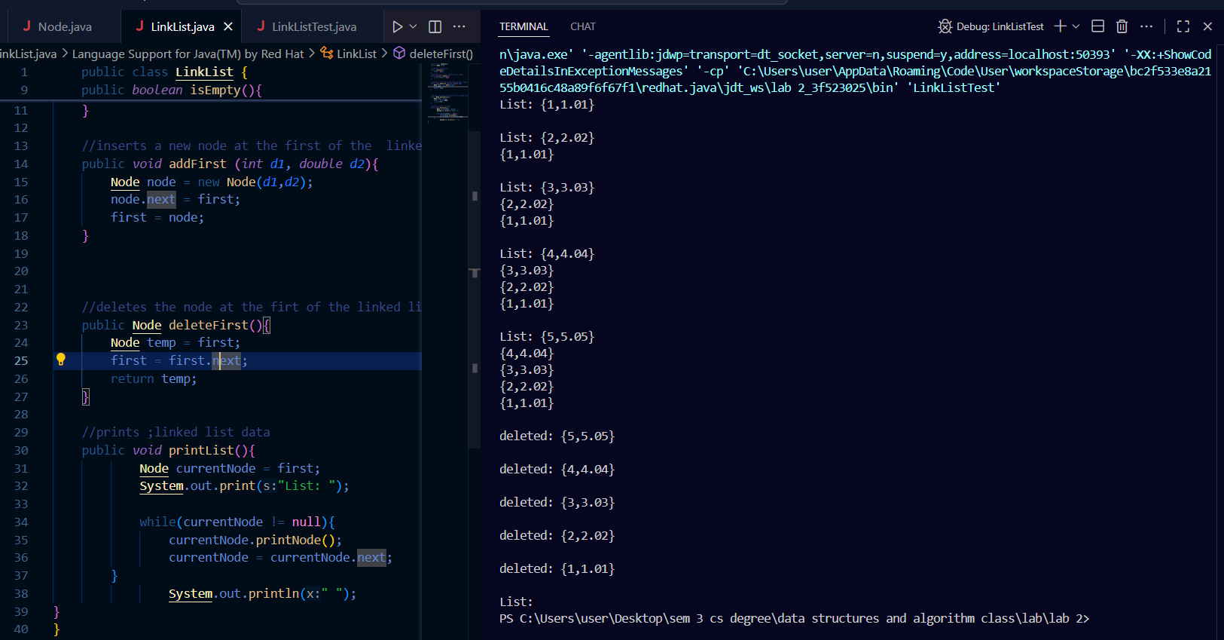

Node.java
public class Node {
//star of class node
//two dofferet types: int and double
public int data1;
public double data2;
Node next;

//constuructor for the node
public Node(int d1, double d2){
data1 = d1;
data2 = d2;
next = null;
}

//print node data
public void printNode(){
System.out.println("{"+ data1 +"," +data2 +"}");

}
}
//end of class node

LinkLIst.java
public class LinkList {
private Node first;

//LinkList constructor
public LinkList(){
first = null;
}
//returnd true if the linkeed list is empty
public boolean isEmpty(){
return first == null;
}

//inserts a new node at the first of the linked list
public void addFirst (int d1, double d2){
Node node = new Node(d1,d2);
node.next = first;
first = node;
}

//deletes the node at the firt of the linked list
public Node deleteFirst(){
Node temp = first;
first = first.next;
return temp;
}

//prints ;linked list data
public void printList(){
Node currentNode = first;
System.out.print("List: ");

while(currentNode != null){
currentNode.printNode();
currentNode = currentNode.next;
}
System.out.println(" ");
}
}

LinkedListTest.java
public class LinkListTest { //start of class linkListTest
public static void main(String[] args){
LinkList list = new LinkList();
list.addFirst(1, 1.01);
list.printList();
list.addFirst(2, 2.02);
list.printList();
list.addFirst(3, 3.03);
list.printList();
list.addFirst(4, 4.04);
list.printList();
list.addFirst(5, 5.05);
list.printList();
while(!list.isEmpty()){
Node deletedLink = list.deleteFirst();
System.out.print("deleted: ");
deletedLink.printNode();
System.out.println("");
}
list.printList();
}

}

TASK 2: APPLICATION of singly linked list

task description
Based on the previous code, you may use it to complete the following tasks.

Estimated Time
[120 Minutes]

- Write the Node class consists of two components of a node (i.e.: element, next), with a default construct and a constructor that accepts an item assigned to the initially declared element variable.

- Write a class called MyLinkedList. The class should have the following:
  - Default constructor
  - Nodes for head and tail

- Implement the following methods (some methods had already been shown in Task 1)
  - public void addFirst(Node e)
  - public void addLast(Node e)
  - public void add(int index, Node e)
  - public Node removeFirst()
  - public Node removeLast()
  - public void printList()
  - public void reverse()

- Write a test program called TestLinkedList that creates a list from MyLinkedList class. Using the methods in (3) , do the following:
  - Add these elements to the linked list using addFirst() method according to the order : a, b, c, d, e
  - Print all the elements in the list.
  - Delete the last value.
  - Print current list.
  - Add ‘f’ at the second position in the linked list.
  - Print current list.
  - Add ‘g’ at the end of the list.
  - Print current list.
  - Delete the first element in the current list.
  - Print current list.
  - Reverse the list.
  - Print the list.
- Compile the program. Execute the program and record the results.
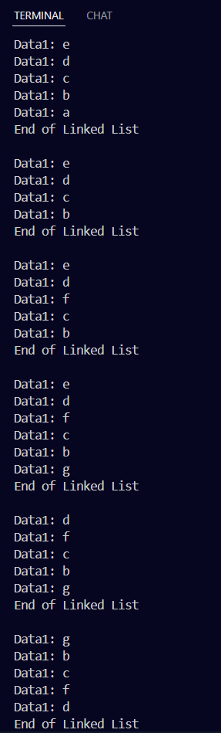

- Submit your codes at epembelajaran. Please ensure your codes are submitted to the correct group.
Output
Data1: e
Data1: d
Data1: c
Data1: b
Data1: a
End of Linked List

Data1: e
Data1: d
Data1: c
Data1: b
End of Linked List

Data1: e
Data1: d
Data1: f
Data1: c
Data1: b
End of Linked List

Data1: e
Data1: d
Data1: f
Data1: c
Data1: b
Data1: g
End of Linked List

Data1: d
Data1: f
Data1: c
Data1: b
Data1: g
End of Linked List

Data1: g
Data1: b
Data1: c
Data1: f
Data1: d
End of Linked List

Node.java
public class Node {

public String data1;
Node next;

// Default constructor
public Node() {
this.data1 = "";
this.next = null;
}

// Constructor for the node
public Node(String d1) {
this.data1 = d1;
this.next = null;
}

public void printMyLinkedList() {
System.out.println("Data1: " + data1);
}
}

LinkedList.java
public class LinkedList {
private Node first;
private Node last;

// Default constructor
public LinkedList() {
first = null;
last = null;
}

// Check if empty
public boolean isEmpty() {
return first == null;
}

// Add at the beginning
public void addFirst(String d1) {
Node node = new Node(d1);
node.next = first;
first = node;
if (last == null) {
last = node;
}
}

// Add at the end
public void addLast(String d1) {
Node node = new Node(d1);
if (isEmpty()) {
first = node;
last = node;
} else {
last.next = node;
last = node;
}
}

// Add at specific index
public void add(int index, String d1) {
if (index == 0) {
addFirst(d1);
return;
}

Node newNode = new Node(d1);
Node current = first;

for (int i = 0; i < index - 1; i++) {
if (current.next == null) {
throw new IndexOutOfBoundsException("Index out of bounds");
}
current = current.next;
}

newNode.next = current.next;
current.next = newNode;
}

// Remove first node
public void removeFirst() {
if (isEmpty()) {
System.out.println("List is empty!");
return;
}
first = first.next;
if (first == null) {
last = null;
}
}

// Remove last node
public void removeLast() {
if (isEmpty()) {
System.out.println("List is empty!");
return;
}

if (first.next == null) {
first = null;
last = null;
return;
}

Node current = first;
while (current.next.next != null) {
current = current.next;
}

current.next = null;
last = current;
}

// Reverse list
public void reverse() {
Node prev = null;
Node current = first;
Node next = null;

while (current != null) {
next = current.next;
current.next = prev;
prev = current;
current = next;
}

first = prev;
}

// Print the list
public void printList() {
Node current = first;
while (current != null) {
current.printMyLinkedList();
current = current.next;
}
System.out.println("End of Linked List\n");
}
}

LinkedListTest.java
public class LinkedListTest {
public static void main(String[] args) {
LinkedList list = new LinkedList();

list.addFirst("a");
list.addFirst("b");
list.addFirst("c");
list.addFirst("d");
list.addFirst("e");
list.printList();

list.removeLast();
list.printList();

list.add(2, "f");
list.printList();

list.addLast("g");
list.printList();

list.removeFirst();
list.printList();

list.reverse();
list.printList();
}
}

